Department of Psychology
California State University, San Bernardino
M.A. Psychological Science
Graduate Student Handbook
Fall 2022

D e p a r t m e n t o f P s y c h o l o g y
C a l i f o r n i a S t a t e U n i v e r s i t y S a n B e r n a r d i n o
SECTION ONE
Letter From The Department Chair. . . . . |  | 3
Letter From The MAPS Director. . . . . |  | 4
MAPS First Year Students. . . . . |  | 4
Two Year Schedule. . . . . |  | 5
Required Coursework. . . . . |  | 6
Grade Requirements. . . . . |  | 7
Student Activities Report |  | 7
Classified Status. . . . . |  | 7
Writing Requirement for Candidacy. . . . . |  | 7
Advancing to Candidacy. . . . . |  | 8
Thesis. . . . . |  | 9
Thesis Review Process |  | 10
Graduation Requirement Check. . . . . |  | 12
Other Important Information. . . . . |  | 12
Leave of Absence. . . . |  | 13
Responsibilities of Faculty Members. . . . . |  | 14
Responsibilities of Students. . . . . |  | 15
Professional Memberships. . . . . |  | 15
Colloquia. . . . . |  | 16
Ethical Requirements. . . . . |  | 17
Plagiarism. . . . . |  | 18
Research Involving Human Subjects . . . . . |  | 19
Graduate Teaching Positions. . . . . |  | 22
Financial Aid. . . . . |  | 23
Research and Travel Funding. . . . . |  | 24
Applying to Doctoral Programs. . . . . |  | 24
Psychology Faculty Research Interests. . . . . |  | 25
SECTION TWO - FORMS
Admission Deferral/Leave of Absence….. |  | I
Advancement To Candidacy – General Concentration….. |  | II
Advancement To Candidacy – Behavioral and Cognitive Neuroscience Concentration |  | III
Change of Program Application |  | IV
Application for Classified Status |  | V
Change in Study Plan….. |  | VI
Thesis Proposal Acceptance Form |  | VII
Petition for Acceptance of Graduate Work |  | VIII
Petition for Waiver of University Regulations |  | IX
Oral Defense Information Form….. |  | X
Student Activity Report Form |  | XI

D e p a r t m e n t o f P s y c h o l o g y
5 5 0 0 U n i v e r s i t y P a r k w a y
S a n B e r n a r d i n o, CA 9 2 4 0 7
P h o n e : ( 9 0 9 ) 5 3 7 - 5 5 7 0
F a x : ( 9 0 9 ) 5 3 7 - 7 0 0 3

Fall 2022
Dear Psychology Graduate Student:
Congratulations on the start of your graduate education in the Department of Psychology at California State University, San Bernardino. On behalf of the faculty and staff, it is with great pride and enthusiasm that I welcome you to the Department of Psychology! Your acceptance to this program is a testament to your academic success and abilities, hard work, and persistence thus far in your educational journey. The applicant pools for our graduate programs are very competitive with many qualified applicants—but you rose to the top, impressed our admissions committees and we are excited to see how brightly you will shine in the coming years!
This is an important milestone in your educational journey and career that will bring many rewarding and challenging experiences. In your graduate program, you will receive state-of-the-art instruction, supervision, and professional training from our exceptional faculty. In turn, you will be asked to devote the time and energy necessary to be successful, and to fulfill your academic promise by embracing the educational challenges and opportunities found inside and outside of the classroom. You will also be asked to represent the department on and off campus responsibly and professionally, with a spirit of collegiality and cooperation. We also invite you to participate in, and contribute to, the intellectual atmosphere in the department by joining our clubs and organizations, attending scheduled department social events and scholarly presentations, and initiating activities that you and other members of our community will find rewarding.
I have no doubt that your educational and professional interests will flourish during your time as a graduate student, and you will leave CSUSB with a wealth of knowledge, lifelong skills, and professional relationships that prepare you for future success. I hope that you grow to feel connected and part of our academic family, not only during your time as a student, but also, once you leave our campus to continue your professional journey. On behalf of the Psychology Department, I welcome you and extend our very best wishes for an outstanding experience in our graduate program. Please feel free to reach out to me if I can be of assistance to you; my door is always open.
Sincerely,
Michael R. Lewin, Ph.D.
Professor and Interim Chair
Department of Psychology
Department of Psychology
5 5 0 0 University Parkway
San B e r n a r d i n o , C A
P h o n e : ( 9 0 9 ) 5 3 7 - 5 5 7 0
F a x : ( 9 0 9 ) 5 3 7 - 7 0 0 3

Fall 2022

Dear New M.A. Psychological Science Students,
Welcome to the master's degree program in Psychological Science. This orientation packet for the 2022-2023 academic year will be useful in navigating the MAPS program. We have updated the information in hopes of providing the most current CSUSB changes. The forms to be used for special requests and for advancement to candidacy can be obtained from the department office or online at http://psychology.csusb.edu/.
We want to welcome you to our wonderful program and hope that you have a very productive and successful year. Feel free to contact me by email at dionisio.amodeo@csusb.edu if you have any questions or concerns, or if you would like to schedule an individual meeting.

Sincerely,
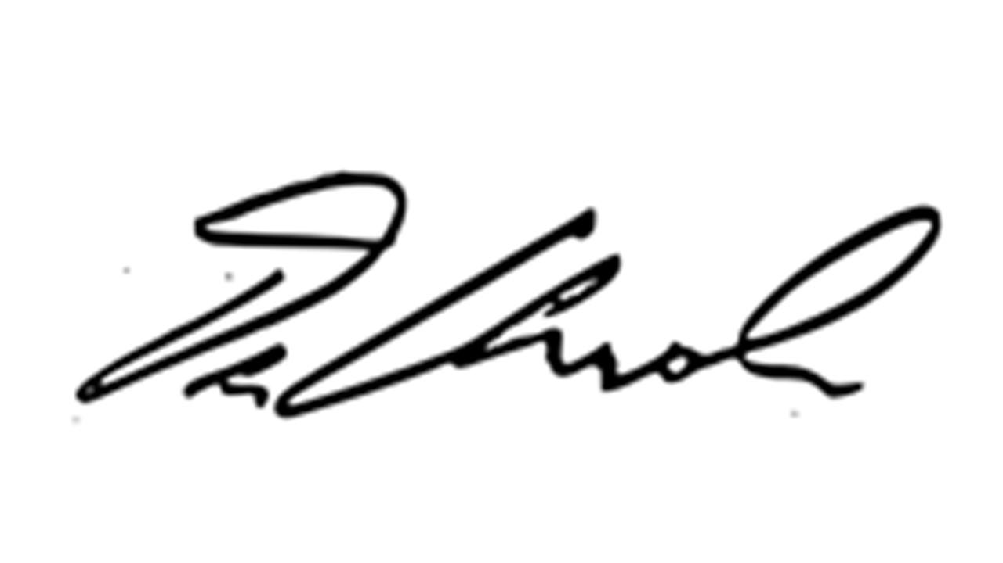

Dionisio Amodeo Ph.D., Director
Master of Arts in Psychological Science Program

Current Psychological Science Faculty:

Dionisio Amodeo, Leslie Amodeo, Brittany Bloodhart. Nicolas Brunet, Kelly Campbell, John Clapper, Cynthia Crawford, Donna Garcia, Cari Goetz,
Jacob Jones, Hideya Koshino, Michael Lewin, Miranda McIntyre, Jason Reimer

MAPS First Year Students 2022 /2023 class

Benjamin Aguilera, Kristof Csaba, Priscilla Cuellar-Rocha
Laila Delgado, Brandon Garibaldi, Negin Ghaffari
Sara Lopez Diaz, Kenya Luna, Kessia Thomas, Maria Velasco

Master of Arts in Psychological Science (MAPS)
Course Schedule for AY 2022-2023
Degree Requirements (34-35)  Program Code (PYSC) |  |  |  |  | First Year MAPS Students  Students Starting in Fall 2021 |  | Second Year MAPS Students  Students Starting in Fall 2020
 |  |  |  |  | Fall 2022 | Spring 2023 | Fall 2023 | Spring 2024
 |  |  |  |  | Course | Course | Course | Course
PSYC 6001 | Proseminar in Psychological Science I |  |  | 2 | PSYC 6001
PSYC 6002 | Proseminar in Psychological Science II |  |  | 1 |  |  | PSYC 6002
PSYC 6640 | Advanced Methods in Psychological Research |  |  | 3 | PSYC 6640
PSYC 6641 | Analysis of Variance |  |  | 4 | PSYC 6641
PSYC 6656 | Advanced Biological Psychology |  |  | 3 |  | PSYC 6656  (See Note 1) |  | PSYC 6656  (See Note 1)
 | Note1: Students may take PSYC 6656 during the spring semester of their first year or during the spring semester of their second year. Students with a Behavioral and Cognitive Neuroscience Concentration are recommended to take PSYC 6656 during their first year.
PSYC 6952  -6955 | Advanced Independent Study 2-5 units for a total of 5) |  |  | 5 |  | PSYC 6952 | PSYC 6953
PSYC Elective | Three units of PSYC 5000-6000-level courses, excluding PSYC 5951-5953, PSYC 6951-6955, PSYC 6121-6125 and PSYC 6891-6893 |  |  | 3 |  |  | PSYC  Elective
Culminating Experience (4 units)
PSYC 6974 | Thesis |  |  | 4 |  |  |  | PSYC 6974
 | Complete and defend original Master’s Thesis
Concentrations (9-10 units)
 | Students must satisfy the requirements of one of the concentrations listed below
General Concentration (10 units)
PSYC 6642 | Regression and Nonparametric Statistics |  |  | 4 |  | PSYC 6642
PSYC 6650 | Advanced Cognitive Psychology |  |  | 3 | PSYC 6650 |  | PSYC 6650
PSYC 6658 | Advanced Social Psychology |  |  | 3 |  | PSYC 6658  (See Note 2) |  | PSYC 6658  (See Note 2)
 | Note 2: Students may take PSYC 6658 during the spring semester of their first year or during the spring semester of their second year. Students with a Social Psychology focus are recommended to take PSYC 6658 during the spring semester of their first year.
Behavioral and Cognitive Neuroscience Concentration (9 units)
Nine units chosen from: |  |  |  |  | ▼ One or two course chosen from▼ |  | ▼ One or two course chosen from▼
 | PSYC 6642 is offered every Spring. We should offer 1 additional of these courses, on a rotating schedule, each semester. |  |  | 9
 | 2022-2023 | 2021-2022
 | Fall 2020: PSYC 6652  Spring 2021: PSYC 5567, PSYC 6642 | Fall 2021: PSYC 5562  Spring 2022: PSYC 5538, PSYC 5539, PSYC 6642
 | Students are recommended to complete two courses during their first year and one course during their second year
PSYC 5538 | Introduction to Psychopharmacology |  | 3 |  |  | PSYC 5538 |  | PSYC 5538
PSYC 5539 | Current Methods in Neuroscience |  | 3 |  |  | PSYC 5539 |  | PSYC 5539
PSYC 5562 | Neural Mechanisms of Learning and Memory |  | 3 |  | PSYC 5562 |  | PSYC 5562
PSYC 5567 | Neural Substrates of Psychiatric Disorders (will be offered Spring 2023) |  | 3
PSYC 6642 | Regression and Nonparametric Statistics |  | 4 |  |  | PSYC 6642 |  | PSYC 6642
PSYC 6652 | Advanced Learning and Motivation (will be offered Fall 2022) |  | 3

PSYC 6630 | Teaching of Psychology | 2 | PSYC 6630 | PSYC 6630
 | PSYC 6630 is required for those students who would like to apply for a Teaching Associate position to teach in the Psychology Department. Students are recommended to take PSYC 6630 during the fall or the spring semester of their first year if they would like to be considered for teaching during their second year.

Required Coursework

The required core content courses in the Psychological Science program are:

Psyc 6001. Proseminar in Psychological Science I
Psyc 6002. Proseminar in Psychological Science II
Psyc 6640. Advanced Methods in Psychological Research Psychology Psyc 6952-6955. Advanced Independent Study (2-5 units for a total of 5) Psyc 6641. Analysis of Variance
Psyc 6656. Advanced Biological Psychology
Three units of PSYC 5000- or 6000-level courses, excluding PSYC 5951-5953, PSYC 6951-6955, PSYC 6121-6125 and PSYC 6891-6893.

Although these classes are generally offered on a yearly basis, we can only guarantee that they will be offered two times in three years; therefore, it is best to take a course as soon as it is offered. However, if your spring, first year semester is too busy, you can delay 6650 or 6652 until your second year.

Culminating Experience
Psyc 6674. Complete and defend original Master's Thesis
General Concentration
Psyc 6642. Regression and Nonparametric Statistics
Psyc 6650. Advanced Cognitive Psychology
Psyc 6658. Advanced Social Psychology
Behavioral and Cognitive Neuroscience Concentration
Nine units chosen from:
Psyc. 5538. Introduction to Psychopharmacology
Psyc 5539. Current Methods in Neuroscience
Psyc 5562. Neural Mechanisms of Learning and Memory
Psyc 5567. Neural Substrates of Psychiatric Disorders
Psyc 6642. Regression and Nonparametric Statistics
Psyc 6652. Advanced Learning and Motivation

Three units of electives must be completed to fulfill the program requirements. The electives do not include Psyc 5951 - 5953 (Independent Study), Psyc 6091 - 6095 (Graduate Research), Psyc 6951 - 6955 (Advanced Independent Study), Psyc 6121 - 6125 (Directed Readings), or Psyc 6891 - 6893 (Externship).
During your first year it would be advantageous to take as many core content courses as possible, along with the statistics/methods sequence. Further, it is also necessary to take at least two units of Advanced Independent Study (Psyc 6952 – 6955) before advancing to candidacy. If you would like to be eligible for a graduate teaching position in the department during your second year, you will first need to take Teaching of Psychology (Psyc 6630), a two unit elective course.

Grade Requirements
An overall GPA of 3.0 is required. If your overall GPA falls below a 3.0, automatic probation will occur. Raising your GPA to a 3.0 must occur in the semester following probation, otherwise you will be declassified from the program.
A grade of B- or better is required for each core course in the program (Psyc 6001, Psyc 6002, Psyc 6640, Psyc 6952-6955, Psyc 6641, Psyc 6656,). A minimum grade of “C” is required for each elective.
Only one course in the graduate program can be repeated for a better grade. You must petition the psychology department for authorization to retake the course. In addition, you must file a petition to repeat a course with graduate studies.

Student Activities Report

All MAPS students will be required to submit a Student Activities Report at the end of their first year and each year thereafter until they graduate. This is a brief report/portfolio that documents your progress and accomplishments in a variety of areas relevant to timely and successful completion this program, as well as later academic and professional success. Copies of the Student Activities Report form can be found at the end of this handbook. You will be notified by email with specific instructions, deadlines, and updated forms at the beginning of Spring semester 2021.

Classified Status
If a student was Conditionally accepted into the program and has completed the conditions of classification based on their Graduate Decision Form, they need to fill out an application for Classified Status. The student and the director must sign the form and the conditions of your acceptance must be verified by the Psychology Department. Students must be classified before they will be allowed to advance to candidacy.
To apply for Classified Status contact the department office or visit the department website (http://psychology.csusb.edu) to download the form.)

Writing Requirement for Graduate Candidacy
Graduate students will be required to have passed a Writing Requirement for Graduate Candidacy (WRGC) before advancing to candidacy within a graduate program. The WRGC requirement can be satisfied through one of two options:
    - Completion of PSYC-6640 (Advanced Methods in Psychological Research) with a grade of B- or better.
    - Demonstration of professional writing via a petition to Graduate Studies.

Advancement to Candidacy

After completing at least 17 units of graduate coursework and successfully completing the writing requirement for graduate candidacy you can formally request Advancement to Candidacy. You should have a thesis advisor when advancing; however it is not necessary to have selected your entire committee. If you change your advisor, committee members, or your program of study after you have advanced to candidacy, you must file a Change in Study Plan form in the department office. Also, If there are any courses you have taken as an unclassified graduate student or transfer student that you want to be counted toward your degree, be sure to file the Petition for Acceptance of Coursework form.

When you apply for advancement to candidacy, your performance in the program will be evaluated by the program coordinator in consultation with your thesis advisor. If your performance is deemed satisfactory, you will be advanced. If your performance is unsatisfactory, you may be declassified from the program.

To be formally advanced to candidacy, a student must, to the satisfaction of the program coordinator, have:
      - achieved classified status;
      - successfully completed 17 units of coursework in the program and maintained a 3.0 (‘B’) GPA in the coursework;
      - selected a graduate advisor to supervise the course of study;
      - satisfactorily completed the writing requirement; for graduate candidacy
      - filed an approved Advancement to Candidacy form;
      - Demonstrated successful research participation with a faculty advisor. Success will be determined by a passing grade in PSYC 6952 (2 units). PSYC 6953 (3 units) will be reserved for the completed thesis proposal after advancement. This requirement can be fulfilled in one of three ways:

        - Student will be required to become familiar with the literature in a research area, which will be related to their thesis research. This could take the form of a partial literature review, an annotated bibliography and/or a presentation of the literature of interest to faculty/student groups.
        - Student will be required to become familiar with several related research literatures if their area of interest is currently undeveloped or if specialized knowledge of particular methodologies requires further investigation for the development of a thesis project.
        - Student will be required to become skilled in certain specialized research methods, which will pertain to their abilities to gather data for the thesis. Examples of such activities could include gathering pilot data to acquire interview skills, knowledge of survey procedures, assessment skills, advanced statistical skills, understanding of content analysis, skills to work with a special population, or advanced physiological measurement skills.

Thesis
Advanced Independent Study

Enroll in Psyc 6953 (Advanced Independent Study) for 3 more units (supervised by your thesis advisor). The purpose of 6953 is to support your work on the thesis proposal. In consultation with the thesis advisor, students will need to arrange for two additional faculty members to
serve on the student’s thesis committee. This three-person committee is responsible for approving the student’s thesis proposal.

When writing the thesis proposal be sure to follow the format instructions provided by the office of Graduate Studies. That office has specific thesis format instructions to which you must adhere. Detailed information is provided in the Thesis/Project Handbook, which is available for download at the following website: http://gradstudies.csusb.edu/

Contact the department office at least two weeks in advance of your anticipated proposal date, so that a Thesis Proposal form can be prepared and a conference room reserved. (Note: The full title of your thesis and the members of your committee must be established by this time in order for your paperwork to be generated.)

Please keep in mind that you must successfully propose and have a final grade posted for Psyc 6953 before enrolling in Psyc 6974.

Thesis

Your next step is to enroll in Psyc 6974 (Thesis). If you do not finish by the end of the semester, a grade of RP (Report in Progress) will be posted until you are finished. Please register for PSYC 6974 only once.

*If you have completed all other course requirements for your degree and are not taking additional courses, you should enroll in Psyc 6990 (Continuous Enrollment) all subsequent semesters until you have finished your thesis to maintain your current status within the program.

Oral Defense

After your thesis is complete (with the exception of typing the final copy), you must schedule your oral defense. Contact the department office at least two weeks in advance of your anticipated defense date, so that an Oral Defense form can be prepared and a conference room reserved. If you made any changes to the title of your thesis and/or the members of your committee from the time that you proposed, please inform the department so that your information can be updated.

According to department policy, you must have completed your oral defense by the deadline to participate in Spring commencement exercises.

Thesis Review Process

All graduate theses, projects and dissertations must be submitted to the Office of Graduate Studies for format review. Thesis content is determined by the faculty committee chair. Theses, projects, and dissertations are published on CSUSB ScholarWorks, the university's electronic repository. Publishing on ScholarWorks has several advantages; as a student, your scholarly achievements can be accessed by a broader audience, and you no longer need to print multiple copies to deliver to the Graduate Studies office for review, a time consuming and costly process.
Document Review Process
Consultations
Students can make an appointment with a thesis reviewer to ask questions about formatting and citations. Meeting with a reviewer before you submit your manuscript saves you time and makes the process go smoother, since formatting errors can be identified and explained more quickly in one-on-one sessions. We have found that students who meet for consultations usually get through the review process much faster. (Questions about content should be directed to your committee chair.)
Please call (909) 537-5058 or email gradstud@csusb.edu to schedule an appointment. Keep in mind that consultations do not constitute a full review of the manuscript and reviewers may not be able to catch all errors. You may make up to two appointments; additional appointments will be scheduled if time permits. Appointments will be limited to 30- minute sessions. There will be no appointments after the consultation deadline.
Committee Certification Form: The Committee Certification Form certifies that your committee has read your manuscript and the content is complete and it is ready to be reviewed for formatting. The form must be turned in to Graduate Studies by the submission deadline. Your manuscript will not be reviewed until we receive the committee certification form at the Graduate Studies office. See the instructions above on how to complete the digital form.
Manuscript Submission Deadline
Your first submission includes three steps:
- Pay the $30 Digital Archiving Fee. The fee can be paid online through MyCoyote Student Center; email the receipt to Graduate Studies at gradstud.csusb.edu. Please see the instructions for paying the Digital Archiving fee: https://www.csusb.edu/graduate-studies/current-students/thesis-project-dissertation/review-process
- Turn in your signed Committee Certification Form. This process is now digital; the student will initiate the process, and the committee chair and graduate coordinator will sign the document through Adobe; it will then automatically be routed to Graduate Studies and all parties will receive a copy via email. (We will continue to accept forms that have been scanned and signed. Email them to gradstud@csusb.edu)
- Submit an electronic copy of your manuscript on CSUSB ScholarWorks. Please note that manuscripts must be submitted as a single file. (See Instructions for Submitting to ScholarWorks: https://libguides.csusb.edu/submit_thesis)

Manuscripts will not be reviewed until all three steps are completed. These steps apply to first submissions only.

The Office of Graduate Studies accepts new manuscripts for review on the first day of the semester through the submission deadline. No new manuscripts may be submitted after the submission deadline, but students who need to make corrections to their previously submitted manuscripts may do so.
Deadlines are 5:00 pm on the deadline date.

Students are encouraged to submit early; during the Spring semester the Office of Graduate Studies goes through about 300 reviews, so the turn-around time may take up to 10 business days.
CSUSB ScholarWorks offers two options for access to your work: open access and restricted access.

- Open Access: Your document can be accessed by anyone via the internet.

- Restricted Access: Only current CSUSB students, staff and faculty can access your manuscript.

Your manuscript will be checked for plagiarism via Turnitin.com and reviewed for formatting by a thesis reviewer. If there are no corrections, the manuscript will immediately be posted on the ScholarWorks repository. Once uploaded, they cannot be removed. Therefore, it is important that manuscripts be complete and final before they are submitted. Oral defense of your thesis and any content changes associated with it should be made prior to submitting on ScholarWorks.
If corrections are required, you will receive an email with a memo attached listing the corrections. Please make the changes and resubmit the corrected manuscript to CSUSB ScholarWorks as soon as possible. Do not wait until the publication deadline – you should be approved for publication by the deadline, not under review. Manuscripts typically go through two to three reviews before they are accepted for publication.
Publication Deadline

All manuscripts must be approved for electronic publication in the electronic depository by the publication deadline. Deadlines are 5:00 pm on the deadline date.

Students whose manuscripts are not accepted for publication by the deadline, as well as those whose manuscripts are rejected, must postpone their graduation and resubmit the following semester. Contact the Office of Graduate Studies to determine the specific formatting review deadlines for the semester in which you wish to graduate.

Submission Process Links

Digital Archiving Fee: https://www.csusb.edu/sites/default/files/How%20to%20pay%20thesis%20archiving%20fee_0.pdf

Committee Certification Form:
https://www.csusb.edu/sites/default/files/Committee%20Certification%20Form%20Instructions_1.pdf

CSUSB Scholar Works:
https://scholarworks.lib.csusb.edu/etd/

Graduation Requirement Check

You must file a graduate requirement check prior to completing your academic work. Please check the deadline date (in the current catalog of courses) for the semester you anticipate you will be graduating. (Note: the office of Records, Registration, and Evaluation cannot process a graduation check until they have your Advancement to Candidacy form).
To participate in the May commencement ceremony, you must have completed all coursework, including completion of the thesis oral defense, by the graduate studies deadline.

Other Important Information

2-Year Limit: graduate students must complete their thesis within two years of enrolling in PSYC-6974.
- Year Limit: Classified graduate students must complete their degree requirements within seven years of admission to the program.
Changes in Program of Study: If you make any changes to your program of study after you have advanced to candidacy (e.g., change your thesis advisor, change an elective course), then you must complete a Request for
Change in Study Plan for Master’s Degree form. The form is available at http://psychology.csusb.edu/.
Communication With the Psychology Department: Please keep the Psychology Department updated with your contact information (e.g., address and phone number). We keep this information on file to use when we need to reach you. Additionally, please ensure that the email address used for the graduate student list serve “psycgrads” is easily accessible since this is the primary way departmental news and updates are relayed.
Leave of Absence: Master’s students must be continuously enrolled until all requirements for the degree are completed, including the thesis. Students who plan to be absent for one semester or more must submit a leave of absence form. The form and policy are available at http://gradstudies.csusb.edu/.
Registration: Graduate students who fail to register in at least one course in the Psychology M.S. program each semester will automatically be declassified. PSYC-6990 (Continuous Enrollment) may be taken if another course is not taken during a given semester. This course can be taken through the College of Extended Learning for a reduced fee, currently $320 per semester.
Repeat of Courses: Classified and conditionally classified graduate students may be permitted to repeat a course at CSUSB that was taken for graduate credit only once and only by petition. The form and policy are available at http://gradstudies.csusb.edu/.
Transfer Units: Program plans may not include more than 9 semester units of work taken in unclassified status or before classified status was attained. If coursework was taken at another university or in extension, no more than 30% of the total program units may be transferred (pending director approval). Furthermore, transfer coursework will only be considered if the university at which it was taken will accept it in its own advanced degree program.
Two Masters Degrees: Students who wish to secure two different master's degrees may do so if the program allows it. At the discretion of the program, credits from one master's degree may be applicable to a second master's degree up to the maximum number of transfer units allowed within each program. In no case shall a student be awarded a given master's degree more than once. Students interested in obtaining two master's degrees should contact Graduate Studies.

Leave of Absence
Master’s students must be continuously enrolled until all requirements for the degree are completed, including the comprehensive exam and the thesis/project (Bulletin P. 332).

Students who plan to be absent for one semester or more must file a leave of absence form with the Office of Graduate Studies. The form and policy are available at http://gradstudies.csusb.edu

Listed below are the four types of leaves and the acceptable duration of the absence. Please note: Students who do not return to CSU, San Bernardino at the conclusion of their planned leaves and those who enroll elsewhere without permission of the Office of the Registrar will be considered to have withdrawn for the university at the end of their last term of regular enrollment.

Medical Leave: Requests must be accompanied by a statement from a medical doctor verifying the reason for the leave and the length of recuperation. The statement should be on the doctor’s letterhead. Leaves for pregnancy are restricted to the term of delivery unless verified medical circumstances indicate a longer time is required for recuperation. Exceptions to the two year limit may be granted under extenuating circumstances.

Military Leave: CSUSB supports students called to active duty in the U.S. Military. The Military Leave Policy and forms are available from the Veterans Success Center.

Planned Educational Leave: Since students usually maintain their catalog rights, courses completed at other institutions must have received prior approval in order to count toward the degree program at CSU, San Bernardino. Therefore, a student must also file a concurrent enrollment form with the Office of Graduate Studies to obtain that approval. Failure to file a concurrent enrollment form may result in coursework not being accepted. Upon return, transcripts must be submitted showing the courses taken. A maximum of four (4) consecutive semesters (6 consecutive quarters) may be approved. (Summer does not count as a term.)

Personal Leave: This option allows time to address personal matters and thus enhance the prospect of successful completion of the academic program. When completing the form, students should briefly describe the reasons for the proposed leave of absence.

Return to the university by the end of your leave. Students returning from a leave of absence earlier than the date approved must complete a “Readmission from a Leave of Absence” form and submit it to the Office of the Registrar. Students who do not return by the end of the approved leave will be discontinued. If you need to extend your leave, you will need to complete a new leave of absence request. Contact the Office of Graduate Studies at (909) 537-5058 if you have questions or need additional information.

Responsibilities of Faculty Members

Since education is a cooperative effort, especially at the graduate level, between faculty and students, both parties must fulfill obligations if the integrity and efficacy of the instructional process are to be preserved.
  - Contribute to and remain abreast of the latest developments in their field.
  - Pursue teaching excellence continually.
  - Treat all students with respect and fairness without regard to age, ancestry, handicap, marital status, national origin, political beliefs, race, religion, gender, sexual orientation, or other factors unrelated to the learning process.
  - Encourage differing viewpoints and demonstrate integrity in evaluating their merit.
  - Attend class regularly and punctually, adhere to the scheduled class and final examination times, and arrange for notification of absence and coverage of classes.
  - Establish and maintain appropriate office hours.
  - Present, early in the term, the following course information:
    - Course objectives and general outline.
    - Classroom procedures to be followed, and expectations concerning class attendance, and proposed dates of major evaluations (including examinations, papers, and other projects.

  - Provide and adhere, within reasonable limits, to the written syllabus of the course.
  - Know course matter thoroughly and prepare and present material conscientiously.
  - Be informed of University services and recommend their use to students when advisable.
  - Follow these policies concerning written work and grades:
    - Grade and return written work promptly.
    - Submit final grades by the scheduled time.
    - Allow students to examine written materials not returned within the term (e.g., final exam, major term papers) and retain such materials for one academic year.

  - Implement procedures for student evaluation of faculty teaching with attention to preserving student anonymity.
  - Behave appropriately when interacting with students so as to maintain a scholarly atmosphere.

Responsibilities of Students

- Prepare for and participate in all class and program activities to the fullest of your abilities.
- Attend classes regularly and punctually.
- Maintain a scholarly, courteous demeanor in class.
- Uphold academic honesty in all activities.
- Notify the instructor as early as possible if prevented from keeping an appointment or carrying out an assignment.
- Discuss with the instructor any class related problem and follow established procedures in the resolutions of these problems.
- Adhere to instructor's and general university policies on attendance, withdrawal, or other special procedures.

It is expected that faculty and students will fulfill their obligations to the instructional process. If, however, a complaint does arise, the parties should meet in an effort to resolve the matter. When such a discussion fails to resolve the problem or is inappropriate given the circumstances, the chairperson of the Department should be contacted. If this contact fails to satisfy the complaint, the college's published procedures should be followed.

Professional Memberships

Graduate students are encouraged to become involved in professional activities. This means, first of all, becoming a student member of regional and national organizations. The cost is usually much less for a student member. Some important organizations are the Western Psychological Association (WPA), the American Psychological Association (APA), the American Psychological Society (APS) and the Society for Neuroscience. You can obtain application forms from the Department Graduate Secretary or the faculty. Other more specialized professional organizations are available too, such as Association of Women in Psychology and Div. 35 (Psychology of Women) of APA.
A second part of being a professional is presenting your research at conferences. WPA holds its annual conference in April, with a November deadline for submissions. APA meets in late August, with a December submission deadline. Neuroscience meets in November, with a April submission deadline. Many CSUSB graduate students have presented projects at conferences. Attending, as well as presenting, is both informative and fun.

Colloquia
Each year there are three or more colloquia hosted by the psychology department or by the College of Social and Behavioral Sciences. Prospective new faculty members who are on the final list of applicants present colloquia as part of their application process. It is extremely important for you to attend these when scheduled. The presentations may include refreshments before or after the talk. We may also take the speaker out to dinner afterwards. Graduate students are welcome and encouraged to come along. All graduate students are expected to attend all of these colloquia. The presentation itself allows the student to hear about a specialized area of research with which he/she might not otherwise come in contact. These colloquia also give the student a chance to see how actual research projects develop. Besides the specific content of the colloquia, the meetings present an opportunity for students to interact with psychologists from other schools and with the psychology faculty in a professional social setting. This may in fact allow you to make contacts for doctoral programs, jobs or may be a way to generate ideas for your required research projects. Finally, besides the educational aspects of the colloquia, students are expected to attend as representatives of the department. Speakers are often not paid, and their only reward is the presence of an attentive audience.

To encourage attendance and involvement the faculty may call on you to act in the role of "student host" for each of the colloquia. Duties may include:
  - Being present at each of the colloquium functions to interact with the guest and see to it that he or she has a relatively pleasant visit. This includes being present at the beginning of the informal gathering before the presentation (usually about a half hour long), and attending the social hour and dinner (if you can afford it) afterward.
  - Helping with some of the incidental details that tend to crop up with some of the visits (such as driving the guest to the airport or to dinner).
  - Encouraging the other graduate students (or professors who are teaching a class at that time) to attend the colloquia and associated events. It is expected that graduate students will attend the colloquia anyway. However, in the past there have been a few students who have been less than diligent in this. We are not impressed by this lack of participation.

Ethical Requirements

Students must exhibit behavior consistent with ethical requirements of the American Psychological Association. The APA considers these ethical requirements to be appropriate for both professionals and graduate students in the field. The following have been identified as the specific areas of concern:

- Students should only provide services, teach, and conduct research within the boundaries of their qualifications based on their education & training.
- Students should not engage in sexual harassment. This is defined as repeated, unwelcome sexual advances or other verbal or physical conduct of a sexual nature, occurring in connection with work or school. Sexual relationships with undergraduates that they are teaching are so likely to be exploitative that they are always unethical.
- Students should not knowingly engage in harassment that is demeaning to another individual contacted through work or school that is based on the other individual's age, gender, race, ethnicity, national origin, religion, sexual orientation, disability, or socioeconomic status.
- Graduate students should avoid dual professional and personal relationships with clients, undergraduate students in the classes they teach, and research subjects who are participating in their projects. In particular, graduate students are expected to avoid dual relationships in which they are in an evaluative position of another student's academic success or may exploit another student for the graduate student's personal gain.
- All students must avoid plagiarism. Citations of all works that influence the student should be documented. Further, data and records should be maintained in a confidential manner. However, data should be maintained in such a way that it can be made available to competent and trained professionals.
- Assessments should be used and administered only by qualified individuals. When using assessment techniques for training or class assignments, the student must accurately describe the nature and usefulness of the assessments.
- All graduate students, like all researchers, should adequately employ informed consent, debriefing, and confidentiality while conducting psychological research. The decisions of the departmental and university institutional review boards regarding human and animal research subjects must be followed.
- When engaged in teaching, graduate students should make every effort to present information fairly and accurately. Every effort should also be made to avoid demeaning students or colleagues who hold different viewpoints.

The Ethical Principles of Psychologists and Code of Conduct is also available in PDF format at http://www.apa.org/ethics/code2002.html

Plagiarism

Graduate students, as future professionals, are expected to uphold all the standards of ethical behavior. One important issue is that of plagiarism. The following description from Nancy Cotton in the English Department of Wake Forest University may help.
“To put your name on a piece of work is to say that it is yours, that the praise or criticism due to it is due to you. To put your name on a piece of work any part of which is not yours is plagiarism, unless that part is clearly marked, and the work from which you have borrowed fully identified.
Plagiarism is a form of theft. Taking words, phrasing, sentence structure, or any other element of the expression of another person's ideas, and using them as if they were yours, is like taking from that person a material possession, something he or she has worked for and earned. Even worse is the appropriation of someone else's ideas. By “ideas” is meant everything from the definition or interpretation of a single word, to the overall approach of an argument. If you paraphrase, you merely translate from his or her language to yours; another person's ideas in your language are still not your ideas. Paraphrase, therefore, without a footnote, is theft, perhaps theft of the worst kind. Here a person loses not a material possession, but something of what characterizes him or her as an individual. Plagiarism is a serious violation of another’s rights whether the amount of material stolen is great or small; it is not a matter of degree. You know how much you would have had to say without someone else’s help; and you know how much you have added on your own. Your responsibility, when you put your name on a piece of work, is simply to distinguish between what is yours and what is not, and to credit those who in any way have contributed.”

We strongly recommend as you begin our program that you complete an online tutorial about plagiarism. USM offers a good one, available at

http://www.lib.usm.edu/legacy/plag/plagiarismtutorial.php The penalty for plagiarism is declassification from the program.

Research Involving Human Subjects

When people are involved as subjects in research or related activities conducted under University auspices, both the Institution and individual researchers are responsible for assuring that the rights and welfare of participants are adequately protected. In compliance with Federal regulations, California State University at San Bernardino has established an Institutional Review Board (IRB) to oversee its obligations with respect to human subjects. In order to cope with its special needs (e.g., running Psychology laboratory studies), the Psychology Department has established a local committee, namely, the Human Subject Review Board (HSRB) to review Psychology students and faculty's research projects involving human subjects. As of June 1, 2006, it is now mandatory that any student proposing to do research with human subjects complete the collaborative IRB Training Initiative (CITI) course available online at the IRB website http://irbcsusb.edu/.
The statements listed below explain the research review procedure for the HSRB and IRB.

  - All research projects run by faculty and students at CSUSB that involve human subjects will be subject to HSRB or IRB approval. No subjects may be run in any study, until this approval has been received.
  - The investigator must prepare a research proposal using the Application to Use Human Subjects in Research form. In order to appropriately answer some of the questions listed in the application form, one may follow the guidelines stated in “Policies and Procedures for Review of Research Involving Human Subjects.” Both the application form and the policy guidelines may be obtained from the IRB website http://irb.csusb.edu/.
  - In many cases, the investigator shall not involve a human subject in a research project without first having obtained the legally effective informed consent of the subject or the subject’s legally authorized representative. Unless a waiver has been approved by the IRB or the HSRB, this informed consent must be obtained and documented in writing. The researcher should retain a copy of the signed consent form. Legally effective informed consent must include information listed on page 4 of “Policies and Procedures for Review of Research Involving Human Subjects.” A sample consent form is given on page 5 of the same document.
  - It is also important to include a debriefing statement. A debriefing statement includes at least the following:
    - The reason for conducting the research.
    - The way to obtain general results of the study.
    - The person to contact if the subject has any questions or concerns related to the research.
Basically, the same rules go for debriefing as for the informed consent.

  - If the research topic is a high risk one (e.g., issues related to abuse or sexuality), it is recommended that the investigator directly submit his/her proposal (including the application form, the informed consent form, and the debriefing statement) to the IRB, otherwise, the investigator may submit the proposal to the local committee HSRB. It is also recommended that the investigator attach a copy of his/her complete research proposal. It will be helpful if the board members need to clarify some points.
  - The proposal submitted to the HSRB will be reviewed by two faculty members in the Psychology Department.
  - The HSRB chair will review the submitted proposal and the suggestions and
comments made by these two faculty members.
  - If the proposal has been submitted to the HSRB, the investigator can expect to hear the HSRB decision within two weeks. Basically, there are three possible outcomes:
    - the proposal is approved by the HSRB,
    - the proposal will be approved if the unclear points are clarified and/or the missing materials are submitted, and
    - the proposal has to be forwarded to the IRB.
  - If the proposal has been submitted to the IRB, the investigator can expect to hear the IRB decision within two weeks. There are also three possible outcomes:
    - the proposal is approved,
    - the proposal will be approved if the unclear points are clarified and/or the missing materials are submitted, and
    - the proposal is not approved.
In all cases, the HSRB chair or the IRB chair will write a memo stating the decision concerning the submitted proposal. In addition to the review decision, the investigator may receive a list of suggestions and comments.
Basically, the suggestions and comments are related to issues concerning human subjects. Occasionally, some suggestions and comments related to the research methodology will be given. It will be clearly stated in the memo what the things are purely suggestions to the investigator and what the things require further clarification before the proposal can be approved.

  - After receiving the memo from the HSRB chair or the IRB chair, if the proposal is approved, the investigator may start collecting data. If the proposal is not approved, the investigator may make appropriate changes in the proposal and submit a rebuttal of the proposal. If the investigator does not agree with the decision made by the HSRB or the IRB, he or she may write a statement including clear justifications. The HSRB chair or the IRB chair may schedule a meeting with the investigator to discuss the points.
  - There are some further points to be noted:
    - If the project lasts longer than one year, the investigator may need to
reapply for approval at the end of each year.
    - If any substantive changes are made in the research prospectus, the HSRB or the IRB must be notified immediately, and a new review may be necessary.
    - If any unanticipated risks to subjects arise, the investigator must immediately notify the IRB or the HSRB.
    - The investigator is required to keep copies of the informed consent forms and data for at least three years.
  - If you have any questions regarding the review procedures, please contact the Departmental IRB representative. Please prepare your proposal in advance. Do not wait until the last minute. The IRB and the HSRB members will try their best to cope with your needs.

Graduate Student Teaching Positions

Child Development 2245, 2246, 2247: Observation and Methods in Child Development Prerequisite Coursework
Psyc-6630: Teaching of Psychology
CD-2260: Early Childhood Development or an equivalent course in Observational Methodology

Psychology 1100: Introduction to Psychology (Supplemental Instruction course) Prerequisite Coursework
Psyc-6630: Teaching of Psychology

Psychology 1101: Psychology as a Major
Prerequisite Coursework
Psyc-6630: Teaching of Psychology

Psychology 2210: Psychological Statistics (SAIL Pre-MARC Adjunct Support Class) Prerequisite Coursework
Psyc-6630: Teaching of Psychology
Psyc-6640: Advanced Methods in Psychological Research Psyc-6641: Analysis of Variance
Psyc-6642: Regression and Nonparametric Statistics

Psychology 3311: Introduction to Experimental Psychology Lab
Prerequisite Coursework
Psyc-6630: Teaching of Psychology
Psyc-6640: Advanced Methods in Psychological Research Psyc-6641: Analysis of Variance
Psyc-6642: Regression and Nonparametric Statistics

PSYC-3363: Biological Psychology (SAIL/pre-MARC/RISE Adjunct Support Class) Prerequisite Coursework
PSYC-6656: Advanced Biological Psychology)
*Must have passed with an “A”

Application to Teach
- Graduate students are strongly encouraged to apply for teaching associate positions within the department.
- Graduate teaching applications are available during the Spring semester.
- Preference will be given to second year students and financial need will be one consideration in the selection process.
- To be considered for teaching, students will also need to submit a one page personal statement and three letters of recommendation from faculty members.

Financial Aid

If you believe you will not be able to pay for all your educational costs, you are encouraged to apply for financial aid. Please contact the Financial Aid Office if you need assistance applying for any of these programs. Students eligible for financial aid typically receive a
“package” of aid from two or more of the programs described below.

State University Grants: State-funded awards that cover a portion of fees for eligible graduate students who are California residents and who are required to pay the State University Fee.
Graduate Equity Fellowships: State-funded awards to students with demonstrated financial needs that are admitted to graduate degree programs. Eligible students are from ethnically underrepresented groups, students with disabilities, and women in academic disciplines where they are underrepresented.
Fellowships and Scholarships: Awarded on the basis of merit and financial need, in addition to other criteria as specified by the donors of each fund. Number, types and application procedures vary from campus to campus. Contact financial aid office for information.
Federal Work-Study Program: Work-study jobs enable eligible students to earn money to help pay for their educational expenses through part-time and summer employment on campus or with an approved off-campus agency.
Federal Student Loans: Various long-term, low-interest student loans are available to eligible applicants. Student loans must be repaid with interest. Federal Perkins Loans may be included in the financial aid “package.” The amount of the loan will vary according to the total amount of financial aid a student is eligible to receive.
Federal William D. Ford Direct Student Loan/Federal Stafford Loan: These loans are “subsidized” if the student has financial need, meaning the federal government pays interest on the loan until the borrower begins repayment, or “unsubsidized” meaning the borrower will be charged interest on the loan from the time it is disbursed until it is paid in full. Additional information is available from the financial aid office.
Except for graduate assistantships, where application to the Psychology Department is made, students should apply directly to the University’s Financial Aid Office.
Graduate students must be enrolled in a minimum of 6 units.
Applications received by the University’s Financial Aid Office prior to March 1 receive primary consideration. Applications are generally accepted on year-round basis and aid awards are made on a “funds available” basis.

Research and Travel Funding

ASI provides funding to support research and travel related to academic growth and development.
Specific examples include research supplies for an independent study, academic course, or honor’s project; presenting at a conference; attending a conference; and travel related to research. Applications are evaluated competitively by the ASI Grant Review Committee and funds are awarded up to $1,000 per submission. Requests are accepted every semester. For more information on the review process, submission deadlines and to download the application, please visit the Graduate Studies website: http:// gradstudies.csusb.edu
OSR Student Grants are awarded to cover costs associated with student research or other creative activity outside the classroom. Applications are evaluated competitively based on the quality of the proposed research/creative activity. To be eligible, students need to be in good academic standing (Cumulative GPA of 3.0 or above) and registered as a full-time student. Students are allowed one grant (up to $500) per degree. For more information on the review process, submission deadlines and to download the application, please visit the Office of Student Research website: http://osr.csusb.edu/ students/studentGrants.html

Applying to Doctoral Programs
The process for applying to doctoral programs is basically the same as applying for master's programs. In addition, however, you must take the GRE’s. The recommended time to take these would be in your 2nd year. The experience of many graduate students who have taken the GRE’s both prior to, and during, our program is that there is some change in the Aptitude scores (Verbal, Quantitative, and Writing) and substantial change in the Psychology score after completing the coursework in our program. Some schools also require the MAT (Miller Analogies Test). Preparation for these exams is recommended and will likely improve your scores. Check with the office of Graduate Studies for any on- campus resources that might be available. Self-help guides and professional prep courses are also an option.
A second step is to decide what type of specialized doctoral program you wish to attend. To get a clear idea it is best to talk with your advisor and faculty working in that area. The primary advantage that we offer students is the opportunity to do research. Having scholarly presentations and publications will dramatically enhance your ability to advance to a quality doctoral program. Letters of recommendation are also important. The usual timing is to ask three professors early in the Fall if they will write recommendations for you. When you give the professor the recommendation forms, make sure that you include: a list of when each application is due, stamped envelopes that include the full address, and be sure to fill out those portions of the recommendation form that you are responsible for.
The next step is to select a list of graduate schools. To help you do this, there is an APA guide to graduate programs in the US and Canada. There is a similar guide put out by the Society for Neuroscience. Select a list of ten or more schools to apply to. These schools should be ones with a good reputation for the program you are interested in (not just a good reputation overall). Your primary concern is to choose a university where you will succeed, so it is essential that you go to a university where you will be doing research that you enjoy and are working for a faculty mentor who you like and respect. For these reasons, it is best to visit the laboratory where you are going to be working prior to accepting a position at that university.

Psychology Faculty Research Interests
Mark Agars, 1999 (Ph.D., Pennsylvania State University) The work family interface, diversity management, gender issues in the workplace, and workplace creativity.
Dionisio A. Amodeo, 2015 (Ph.D., University of Illinois, Chicago) Rodent models of autism spectrum disorder, repetitive behaviors and cognitive inflexibility. Focusing on the serotonergic system.
Leslie Amodeo, 2016 (Ph.D., University of Illinois at Chicago) Focusing on the understanding the neurocognitive aspects of adolescent development and how drugs of abuse, such as alcohol and psychostimulants, can manipulate that neuro-maturational trajectory. Additionally, focusing on the neural circuitry underlying how we learn and make decisions using a rodent model.
Manijeh Badiee , 2013 (Ph.D., University of Nebraska-Lincoln) Women's empowerment and activism, community-based research, multicultural issues in mental health treatment, relational approaches to psychotherapy, and sexual assault prevention.
Brittany Bloodhart, 2013 (Ph.D., Pennsylvania State University) How social processes motivate engagement in or denial of social and environmental injustices, and how attitudes about the environment are related to attitudes about sexism, racism, and other forms of prejudice. Looking at the role of moral values, moral emotions (e.g., empathy), social identity, and system justifications in attitudes toward sustainable and pro-environmental behaviors, and on several intervention programs to increase gender equity in academia.
Manpreet Brar, 2020 (Ph.D., University of California, Los Angeles) Adolescent development and experiences with discrimination, youth civic engagement, intergroup relations, and marginalization across multiple social identities; intersectionality.
Kelly Campbell, 2008 (Ph.D., University of Georgia) Interpersonal relationships (specifically couple rituals, commitment, infidelity, and marriage), happiness, and cultural diversity.
David V. Chavez, 1988 (Ph.D., University of California, Berkeley) Ethnicity and mental health; developmental psychopathology, violence in families and children, and preventative psychology.
Yuchin Chien, 1989 (Ph.D., Cornell University) Experimental study of (1) language acquisition from a cross-linguistic perspective and (2) the interaction between language- specific features and cognition.
John Clapper, 2002 (Ph.D., Stanford University) Cognitive psychology, categories and concepts, unsupervised learning, attention and memory organization, computational models of human learning.
Cynthia A. Crawford, 1996 (Ph.D., University of Kentucky) Animal and human models of drug addiction; second messenger system pharmacology; developmental neuropsychopharmacology

Ismael Diaz, 2013 (Ph.D, Texas A&M University ) Occupational Health Psychology (OHP); leader and supervisor positive treatment and mistreatment; communication technology attitudes, usage, and employee outcomes; employee attitudes and well-being; contextual performance; and incivility and mistreatment at work.
Stacy Forcino, 2010 (Ph.D., Idaho State University) Treatment of common problems of childhood (e.g., noncompliance, bedtime problems, toileting training difficulty); Treatment of clinically significant problems of childhood (e.g., Oppositional Defiant Disorder, ADHD, sleep disorders, elimination disorders); Parent training; Behavior therapy/ Applied behavior analysis.
Donna Garcia, 2009 (Ph.D, University of Kansas) The self-perpetuating nature of social inequality via its effects on human functioning (e.g., motivation, aspirations, achievement, self-regulation, and psychological and physiological well-being).
Janelle Gilbert, 1995 (Ph.D., George Mason University) Organizational processes, climate and culture; group dynamics and composition; work attitudes; and leadership development.
Cari Goetz, 2014 (Ph.D. University of Texas at Austin) Evolutionary Psychology; human mating behavior and cognition; evolutionary influences on social behavior.
Pablo Gomez, 2003 (Ph.D. Northwestern University) Perceptual decision making, mathematical modeling, bayesian statistics, visual word recognition.
Christina Hassija, 2013 (Ph.D., University of Wyoming) Trauma Exposure among interpersonal violence and combat populations; Posttraumatic Stress Disorder and other trauma-related sequelae; Mechanisms associated with risk and resiliency following trauma exposure; Cognitive appraisals and meaning making.
Jacob Jones, 2016 (Ph.D., University of Florida) Neuropsychology, Parkinson's disease, neuroimaging, cognitive impairment, microbiome, longitudinal modeling of neuropsychiatric symptoms in neurodegenerative disorders.
Laura Kamptner, 1984 (Ph.D., Michigan State University) Attachment, sibling relationships, personal possessions and their meanings, identity development, early childhood development and education, parenting, issues in human development.
Hideya Koshino, 1994 (Ph.D., University of Kansas) Visual attention and working memory, both the traditional cognitive/experimental and cognitive neuroscience approaches.
Janet L. Kottke, 1984 (Ph.D., Iowa State University) Personnel selection, diversity, diversity management, models or organizational change, business ethics, and measurement.
Michael Lewin, 1995 (Ph.D., Oklahoma State University) Early Maladaptive Schemas and Cognitive Vulnerability; Schema Therapy; Cognitive Behavioral Therapy; Anxiety.
Lisa Looney, (2003, Ph.D., University of Maryland) Achievement motivation, particularly in educational contexts; Processes by which teachers' beliefs and emotional support facilitate students' interest in class, prosocial behavior, and academic achievement; Teachers' self-processes (e.g., self-efficacy, self-worth) and the role of context in the development of self-beliefs; Organizational culture and its role in motivation.
Miranda M. McIntyre, 2018 (Ph.D., Purdue University) Social psychology, personality and individual differences, social cognition, person-environment fit, STEM interest and participation, gender differences, psychometrics and measurement.
Sanders A. McDougall, 1991 (Ph.D., University of Kentucky) Psychopharmacology, developmental psychobiology, animal learning and memory.
Stacy Morris, 2018 (Ph.D., Boston College) Adolescent and young adult civic engagement, community involvement, social activism; awareness of systemic social inequities and civic action aimed to dismantle them; teacher and mentor support of youth engagement; mixed- and multi-methods.
Jason F. Reimer, 2001 (Ph.D., University of Nebraska) Language and memory development, visual word recognition in children and adults, reading acquisition, development of cognitive inhibition.
Robert Ricco, 1992 (Ph.D., Temple University) Cognitive development; logical thinking across the lifespan; argumentation and critical thinking; metacognition; personal epistemology; parent cognition.
Maria Santos, 2016 (Ph.D., University of Wisconsin-Milwaukee) Evidence-based psychotherapies (with emphasis on Behavioral Activation for depression), psychotherapy treatment outcome and process, Latino mental health, community mental health, depression, early psychosis.
Kenneth S. Shultz, 1992 (Ph.D., Wayne State University) Personnel selection and job analysis, applied psychological measurement, older worker and retirement issues.
Jodie Ullman, 1996 (Ph.D., University of California, Los Angeles) Applied multivariate statistical analysis with emphasis on structural equation modeling. Research design and methodology. Longitudinal patterns of substance use.
Amy A. van Schagen, 2016 (Ph.D., University of North Carolina at Greensboro) Early childhood education (ECE) specifically teacher development and work environments, access to high quality ECE for marginalized groups, and racial, ethnic, and cultural diversity.
Amanda Wilcox-Herzog, 1999 (Ph.D. Purdue University) Interests include contextual factors that contribute to quality in early childhood programs, teacher development, and the
relationship between teachers’ beliefs and actions.
Eugene H. Wong, 1991 (Ph.D., University of California, Riverside) Social and personality development during childhood. Specifically, the development of achievement motivation in the academic and sports setting. Self-concept and academic achievement

The following forms can be downloaded at

https://csbs.csusb.edu/psychology
(Psychology Department forms)

or

https://www.csusb.edu/graduate-studies/current-students/forms (Graduate Studies forms)

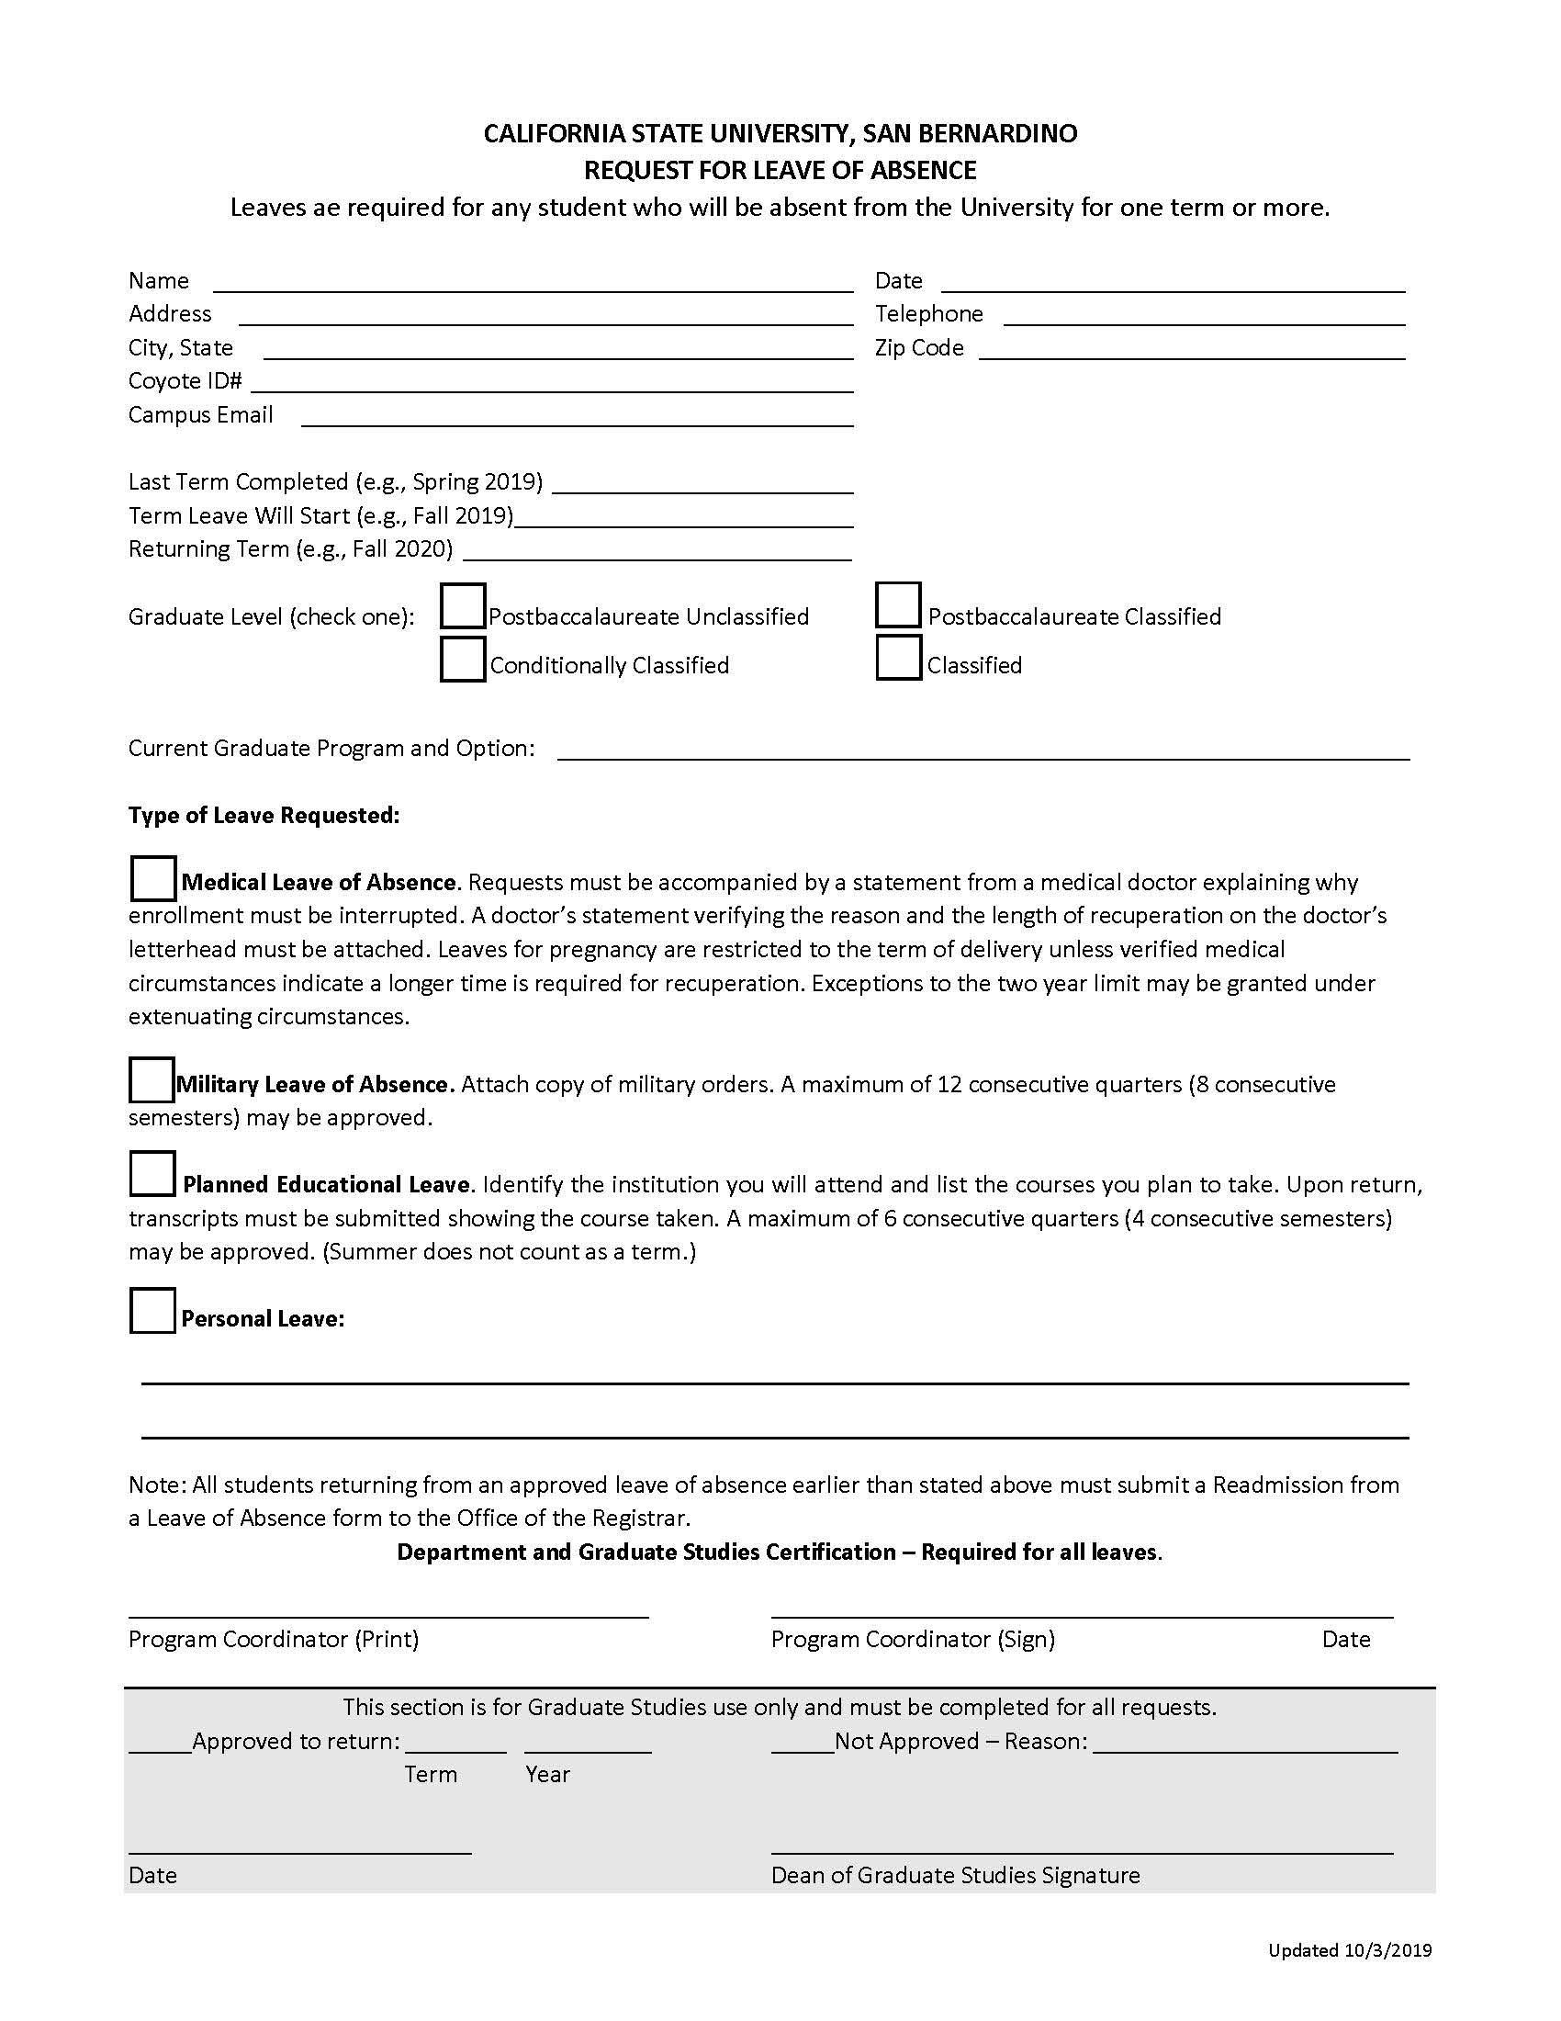
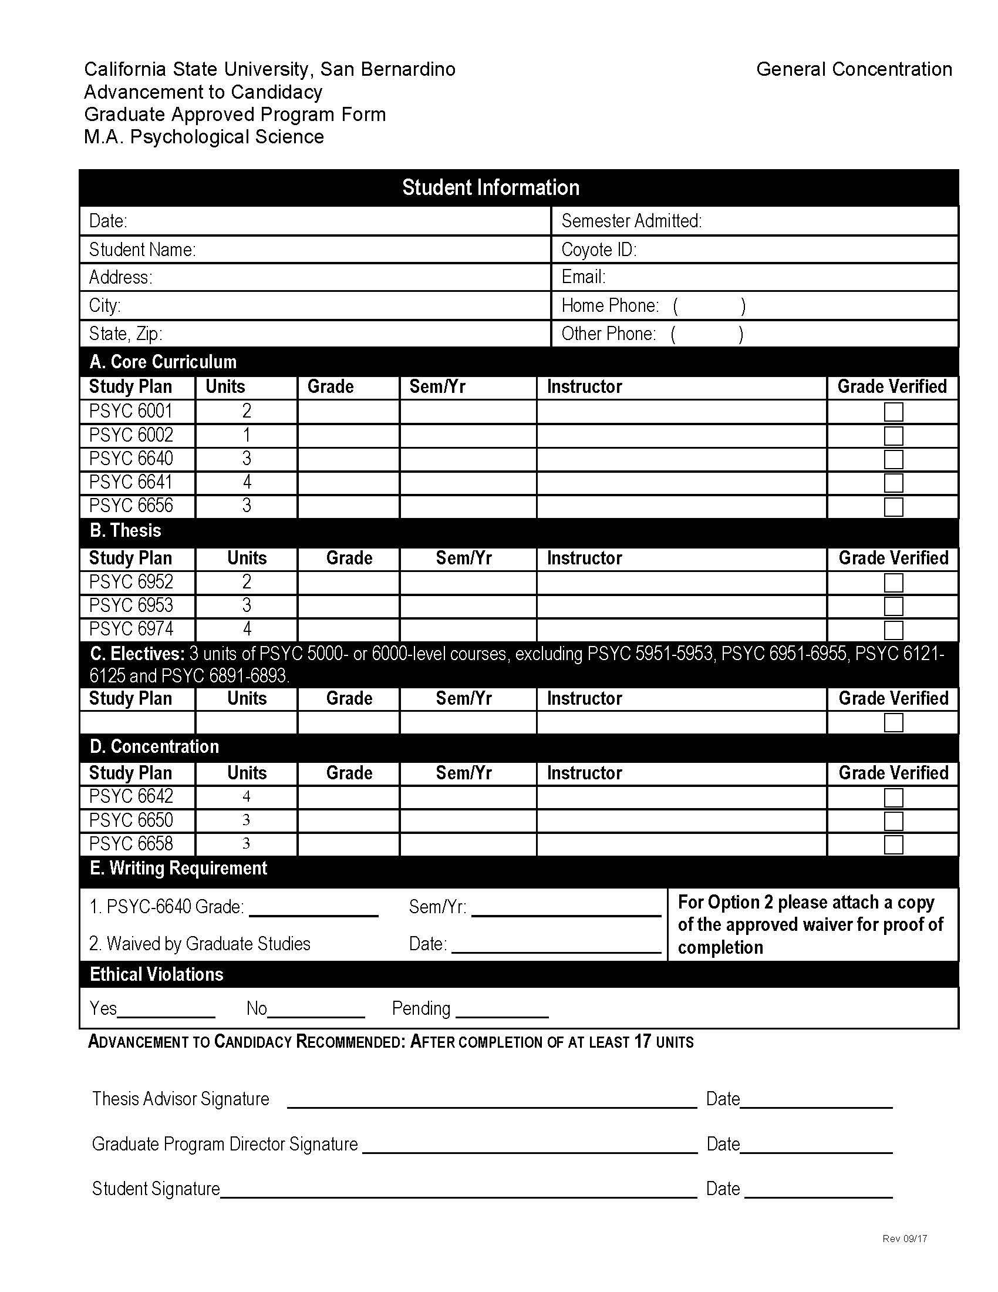
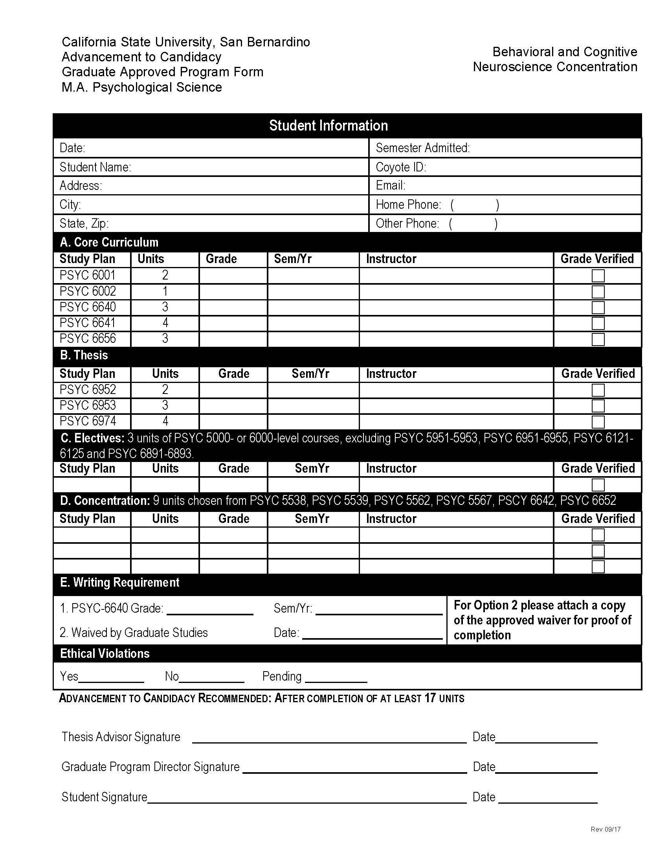
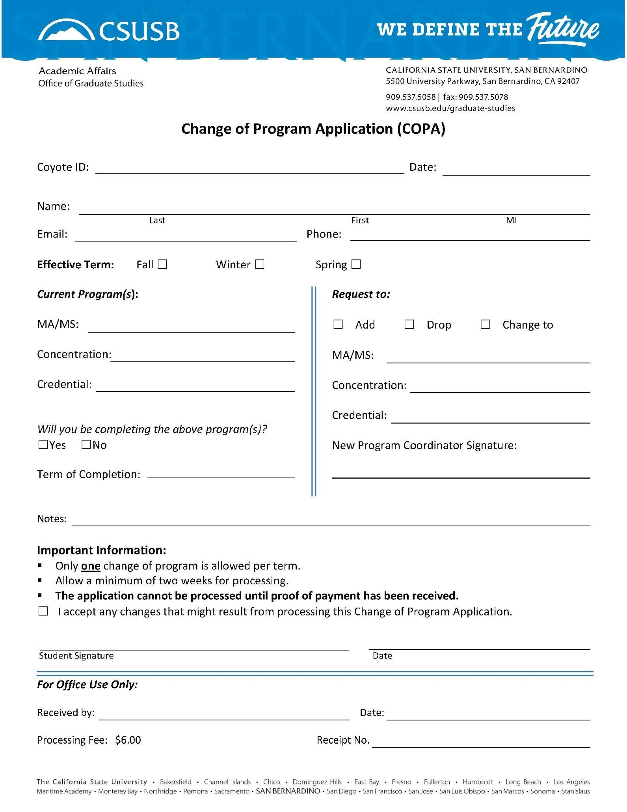

APPLICATION FOR CLASSIFIED STATUS

Name: Date:

Coyote ID: Email:

Program:

I have met the following as specified in my letter of acceptance:

COURSE | SEMESTER TAKEN | GRADE RECEIVED
1.
2.
3.
4.

- Other

SIGNATURE OF STUDENT

I certify that the conditions of classification have been met.

SIGNATURE OF DIRECTOR

DEPARTMENT OF PSYCHOLOGY
REQUEST FOR CHANGE IN STUDY PLAN FOR MASTER’S DEGREE
(Classified Graduate Students Only)

Name: Coyote ID:

Address: Tel #:

Email:

Psychology Master’s Program:

List course names, numbers, and units, and/or thesis committee chair & members

From To

State reason for request:

Student Signature

*********************************************************************************************

APPROVED DENIED

Faculty Thesis Chair: Date:

Graduate Program Director: Date:

Department of Psychology
Thesis Proposal Acceptance Form

Name: Coyote ID:

Has submitted a thesis proposal entitled:

Thesis Committee:

, Chair

Date of Acceptance:

Time:
Location:

cc: Student – original Yuchin Chien – copy
Thesis chair – copy Graduate Secretary – copy Student file – copy

Input on to db
Initials
PETITION FOR ACCEPTANCE OF COURSEWORK
TAKEN AS AN UNCLASSIFIED POST BACCALAUREATE/TRANSFER
STUDENT TO PSYCHOLOGY M.A. OR M.S. DEGREE

DATE
NAME COYOTE ID ADDRESS EMAIL CITY & STATE DEGREE PROGRAM

I hereby petition for acceptance of the following courses taken as an unclassified graduate student to be
considered as graduate work in fulfillment of the requirements for the above-mentioned Degree in Psychology.

These courses may include up to 13 units of extension and transfer credit from other colleges OR up to 12 units of work taken in unclassified status.
Title Department University Course # Units Grade
1.
2.
3.
4.

STUDENT SIGNATURE

GRADUATE PROGRAM DIRECTOR

cc: 1. Admissions & Records, attn: Graduate evaluator
  - Department
  - Student
California State University, San Bernardino (CSUSB) Postbaccalaureate/Graduate Petition for Waiver of University Regulations PLEASE TYPE OR PRINT CLEARLY
Name Street Address City, State, Zip
Date Telephone Coyote ID#
Coyote Email @coyote.csusb.edu

I am enrolled in the following degree: _

Ihereby petition for wavier of the following University regulation:
- Waiver of the Graduate Entrance Writing Requirement. Documentation required
If submitting a writing sample (please check one): DI would like to be contacted to pick up my writing sample
DI would like Graduate Studies to recycle/shred my writing sample
- Waiver of the 12 unit limit prior to classification.
- Wavier of the 7 year limit on applicable coursework.
Requires certification of currency by faculty member. See instructions for wording. List all courses to be waived:
------------------------
- Extension of time to complete an incomplete course.
Course number and title: Incomplete received: Qtr: Instructor Signature Extended to Qtr Year:
Year: _
- Retroactive Withdrawal for Qtr:
Year:
Documentation required
List Courses:
Instructor's Signature
Instructor's Signature Instructor's Signature
f. Other:

----------------------------------
Student's Statement. (Indicate why you feel this petition should be granted. Attach additional page if necessary.)

I certify that I have read the attached information sheet pertaining to the waiver of University regulations that I am requesting, have attached all pertinent information and required documentation to support my request, and have obtained all necessary signatures of certification.

Student's Signature

Program Certification.

Graduate Program Coordinator's Signature

Approved Reason:
Not Approved

Dean of Graduate Studies Signature Date
Distribution: Records, Office of Graduate Studies, Graduate Coordinator, Program Office, Student Updated 10/10

DEPARTMENT OF PSYCHOLOGY
ORAL DEFENSE OF THESIS INFORMATION FORM

Today’s Date: Student Name: Coyote ID: Date of Orals: Time:

Title of Thesis:

Location:
Thesis Committee: , Chair

Orals Passed: Yes No

Signature of Committee Chair Date

CSUSB M.A. Program in Psychological Science Student Activity Report Form
Due: TBA

Student Name Advisor Name

Student Signature Advisor Signature

Date Date

CSUSB MAPS Program Student Activity Report Form

Name Date _

- Please answer the following on a separate sheet. Be sure to keep your answers brief.

  - What progress have you made toward identifying (and beginning work) with a primary (thesis) advisor? If you have selected a specific advisor, please identity.

  - Briefly summarize your involvement in research this year. List any projects you have been in- volved in, the faculty members you are working with (if other than your advisor), and describe any steps, e.g., collection of pilot data, analysis and design, literature review, etc., completed so far.

  - What progress have you made toward identifying your thesis topic (area, not specific research question)? If you have identified a thesis topic, please describe.

  - Are you a member in one or more relevant professional organizations? If yes, please list.

  - Indicate whether you have completed each of the following steps toward the Ph.D. application and/or describe your progress so far.

    - take/schedule GRE
    - identify area(s) of interest for the Ph.D.
    - identify Ph.D. programs of interest, possible advisors there
    - draft a research statement/statement of interests
    - identify letter writers (compile useful information for the recommender)

  - If you been an author on any scholarly publications, please list here. Indicate whether the publi- cation was peer-reviewed. Are you currently working on any article(s) you hope to eventually submit for publication? If yes, describe briefly.

  - Have you given (or are you planning to give) any posters or presentations at professional meet- ings this year? If yes, describe briefly.

  - Have you completed any form of additional training (e.g., workshops, special classes, etc.) in special research skills beyond basic requirements in the last year, such as writing, statistics, re- search presentations, teaching, etc. If yes, describe briefly.

  - Attach a copy of your CV.

  - Briefly describe your anticipated timeline for progress toward completing your thesis, gradua- tion.

List your grades in the following courses (attach unofficial transcript):
Psych 641 – Analysis of Variance
Psych 642 – Regression and Nonparametric Statistics
Psych 640 – Advanced Methods in Psychological Research
Psych 656 – Advanced Biological Psychology
Psych 650 – Advanced Cognitive Psychology
Psych 658 – Advanced Personality and Social Psychology
Other options/substitutions :

Feedback re this form, evaluation process, etc.
Please attach on separate sheet, or email to jclappe@csusb.edu.

